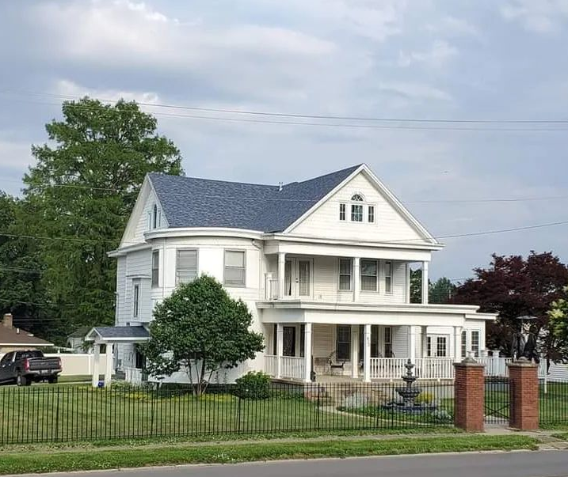
402 S Cross, Robinson, IL
$439,000

This property is rich with history and elegance. Inside you will find original woodwork, leaded windows and abundance of square footage. The 1st floor contains foyer, living room with fireplace, round family room, large dining room, half bath, sunroom and kitchen. The kitchen has heated tile floor, Amish built cabinets, granite countertops and breakfast nook. Four bedrooms, four baths can be found at the top of the wide wooden staircase on the 2nd floor. The 3rd floor has a suite including living room, kitchette, bath and bedroom, as well as washer/dryer hookups. Recreation room, 2 bedrooms and bath are in the basement, along with washer/dryer hookups and water softener. The basement has been professionally water proofed by Woods Basement Systems; providing a life time warranty. The corner location with it’s wrought iron fencing, fountain, large front porch, upper balcony, and back patio with built in grill offers unlimited outdoor entertainment. One car 10’ x 20’ detached garage with concrete floor and viynl siding. Two car detached 20’ x 22’ with concrete floor, garage door opener and vinyl siding.

